Colby Cruise Data Spreadsheet Queries/Inconsistencies

1. **2017 date format** was different from the other years.
   * In 2017 it was yyyymmdd
   * In every other year it was mm/dd/yyyy
   * I changed the format to mm/dd/yyyy in both the CTD-2017 and CTD all years sheets, but can do it the other way if necessary. DAVID: which date format would you like to use?
2. **2012 & 2013 columns** were different from the other years
   * They don’t include a conductivity column (which I think leads to the inconsistencies in the next two points)
   * I added in a conductivity column between depth and temperature (consistent with the other sheets)
3. **2013 columns misaligned** in CTD-2013
   * I think rows 2 - 1634 (cruise on 9/10/2013) should be moved 1 column to the left i.e. the data that are in the salinity column should be in the temperature column, etc.
   * I shifted the above rows 1 column to the left
4. **Columns misaligned in CTD all years**
   * The rows are from 2013 *but* they are all the data *except* from the cruise on 9/10/2013 i.e. the opposite to the point above (but I think this can be explained by the presence of a conductivity column in the all years sheet, but not the 2013 sheet).
   * In this case, I think rows 5602 to 28819 should be moved 1 column to the right.
   * I shifted the above rows 1 column to the right
5. **2013 dates** included 3 from 2017
   * The first three entries for 9/17 were 9/17/2017 within the CTD-2013 sheet (and the corresponding section in the CTD all years sheet).
   * I changed these to 2013
6. Turbidity and beam c have step changes in their values from 2015 onwards:

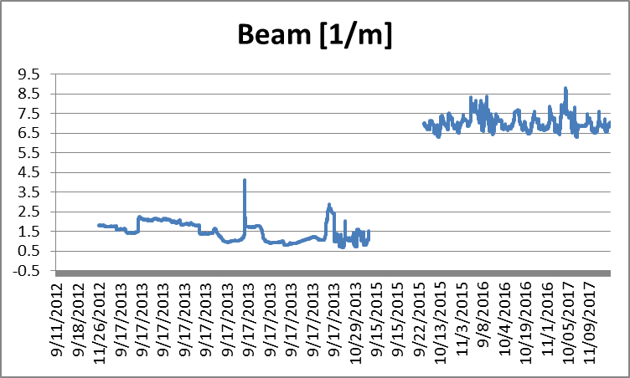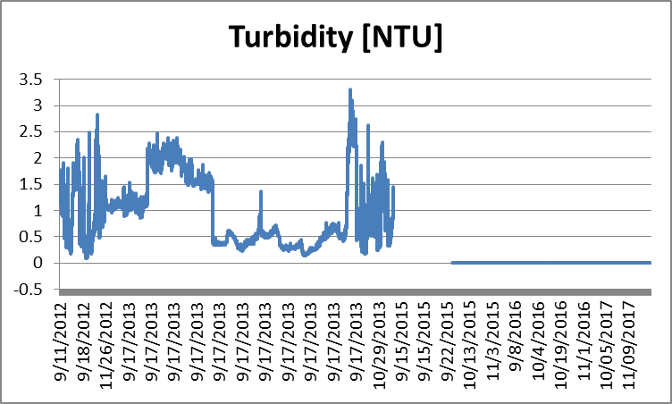

* + I have no idea what is going on here.